Sample programming

1. 1) Print a sample welcome message to greet the user
2. Get the user name at run time and greet them

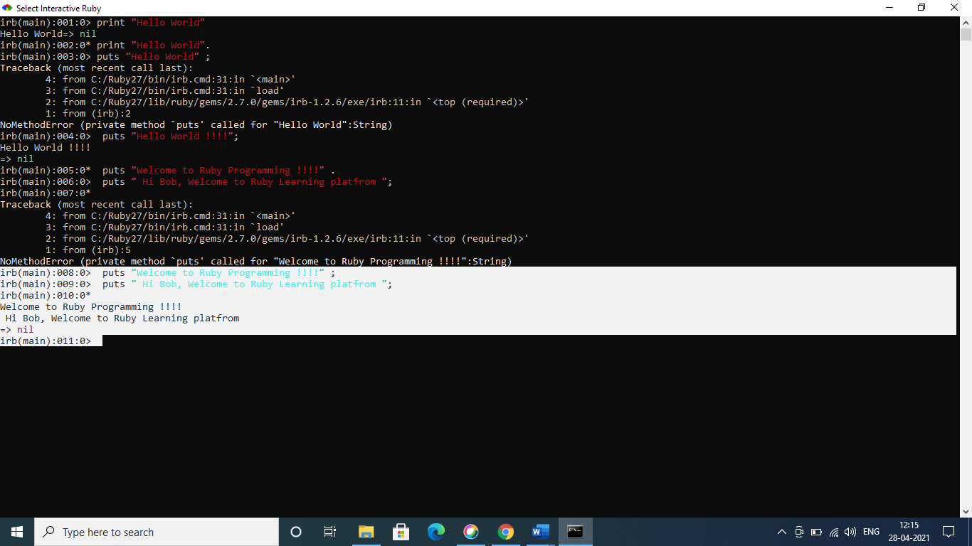

3) Working with numbers – Create two variables (float) perform multiplication and display the output

Output:



4) Local variables and global variables

* 1. Create two variables one is local variable and another is global variable( starts with $)
  2. Create two methods and resign the local variables and print local variable and global variable from both the methods.

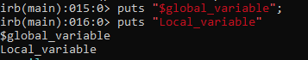

1. 8) Working with strings
   1. Create a string “Ruby Programming”

v

b) Print out the total length of the string

output:

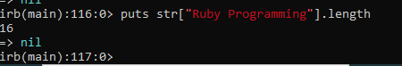

3) Split the string one character each

